H.T No
Regulations:
A18

Sreenidhi Institute of Science and Technology
(An Autonomous Institution)
Code No: 7C303 Date: 04-Sept-2024 (FN)

B.Tech II-Year I- Semester External Examination, Sept - 2024 (Supplementary)
SIGNALS AND SYSTEMS (ECE and ECM)

Time: 3 Hours Max.Marks:70

Note: a) No additional answer sheets will be provided.
b) All sub-parts of a question must be answered at one place only, otherwise it will not be valued.
c) Missing data can be assumed suitably.

Bloom's Cognitive Levels of Learning (BCLL)

Remember | L1 | Apply | L3 | Evaluate | L5
Understand | L2 | Analyze | L4 | Create | L6

Part - A Max.Marks:20
Answer all QUESTIONS

 |  | BCLL | CO(s) | Marks
1 | What is meant by orthogonal signal space? | L1 | CO1 | [2M]
2 | Write the Fourier series expressions for even, odd and half-wave symmetries. | L1 | CO2 | [2M]
3 | Distinguish Linear Time Invariant and Linear Time Variant Systems. | L4 | CO3 | [2M]
4 | Distinguish between convolution and correlation. | L1 | CO4 | [2M]
5 | Write the statement of Sampling Theorem. | L1 | CO5 | [2M]
6 | Draw the ROC of Z-Transform of a left side sequence and right side sequences in separate diagrams. | L1 | CO6 | [2M]
7 | Describe Hilbert Transform. | L1 | CO2 | [2M]
8 | Define filter. Draw the spectrum of ideal LPF. | L1 | CO3 | [2M]
9 | What is meant by Aliasing Effect? | L1 | CO5 | [2M]
10 | Find the convolution between δ(t-1) and δ(t+1)-δ(t). | L2 | CO4 | [2M]
Part – B Max.Marks:50
ANSWER ANY FIVE QUESTIONS. EACH QUESTION CARRIES 10 MARKS.

 |  |  | BCLL | CO(s) | Marks
11. | a) | Express the following signal f(t) in terms of sin(t) using approximation and evaluate mean square error.  f(t) = 1.5 for 0 ≤ t < π  = -1.5 for π ≤ t < 2 π. | L3 | CO1 | [5M]
 | b) | Find the energy, power, even and odd components of the signal u(t). | L2 | CO1 | [5M]
12. |  | Obtain the Fourier components of the periodic rectangular wave form given below.  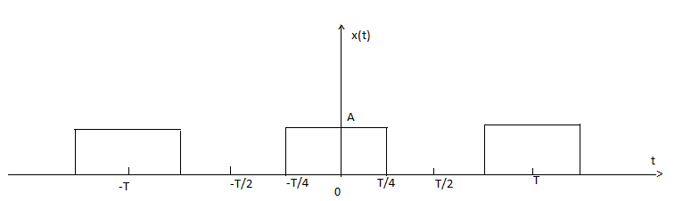 | L2 | CO2 | [10M]
13. | a) | Check the following systems for linearity and time invariance.  i) y(t) = t²u(t) ii) y[n] = nx[n] | L3 | CO3 | [5M]
 | b) | Write the classification of systems. | L3 | CO3 | [5M]
14. | a) | Explain how convolution is performed using Graphical procedure. | L3 | CO4 | [5M]
 | b) | The input and the impulse response to the system are given by x(t)=u(t+2) and h(t)=u(t-3). Determine the output of the system. | L3 | CO4 | [5M]
15. | a) | Prove sampling theorem for band limited signals. | L2 | CO5 | [5M]
 | b) | What is the need of sampling? List types of sampling techniques. | L3 | CO5 | [5M]
16. | a) | Derive the relation between Laplace and Z-Transform. | L4 | CO6 | [5M]
 | b) | Prove that the sequences  i)x(n)=a^{n}u(n) ii) x(n)-a^{n}u(-n-1) have the same X(z) and differ only in ROC. Also plot their ROCs. | L3 | CO6 | [5M]
17. | a) | Evaluate the integral . | L3 | CO1 | [4M]
 | b) | State and prove the Parseval’s relation for continuous time signals. | L3 | CO2 | [3M]
 | c) | Write the conditions for the existence of Fourier series. | L4 | CO3 | [3M]
18. | a) | Explain initial and final value theorems Using Laplace Transform. | L2 | CO4 | [4M]
 | b) | Explain about Flat top Sampling. | L3 | CO5 | [3M]
 | c) | Explain constraints on ROC for various classes of signals. | L2 | CO6 | [3M]

-- 00 -- 00 –

